

# Task 2 – Credit Submission

Student Number: 103181157  
Student Name: Nguyen Nam Tung

### Credit 2a

Paste your screen capture(s) for this task here.

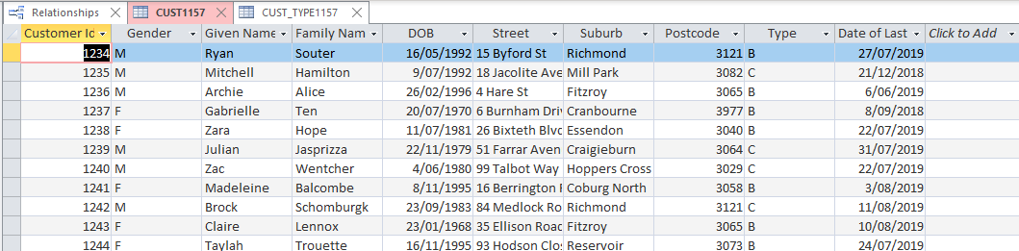

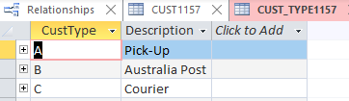

### Credit 2b

Paste your screen capture(s) for this task here.

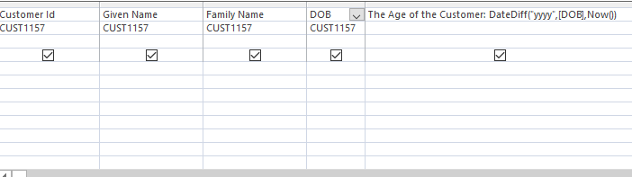

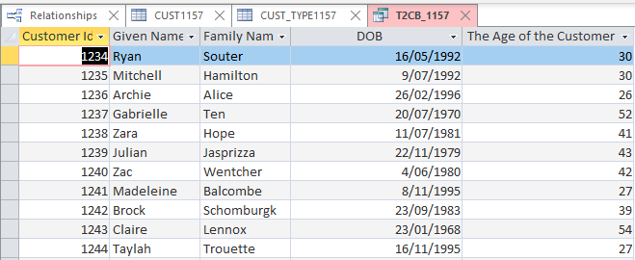

### Credit 2c

Paste your screen capture(s) for this task here.

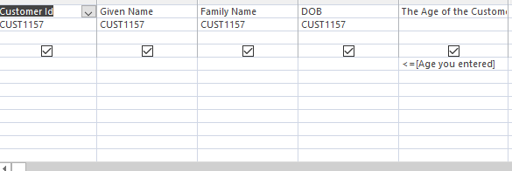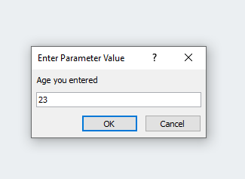

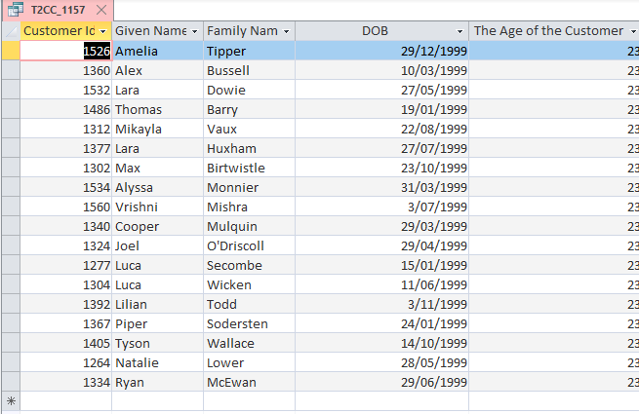

### Credit 2d

Paste your screen capture(s) for this task here.

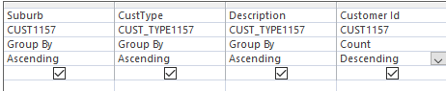

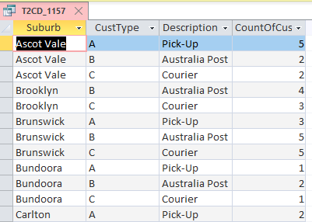

### Credit 2e

Paste your screen capture(s) for this task here.

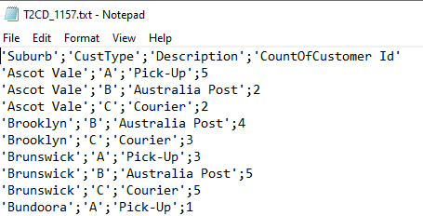

### Credit 2f

Paste your screen capture(s) for this task here.



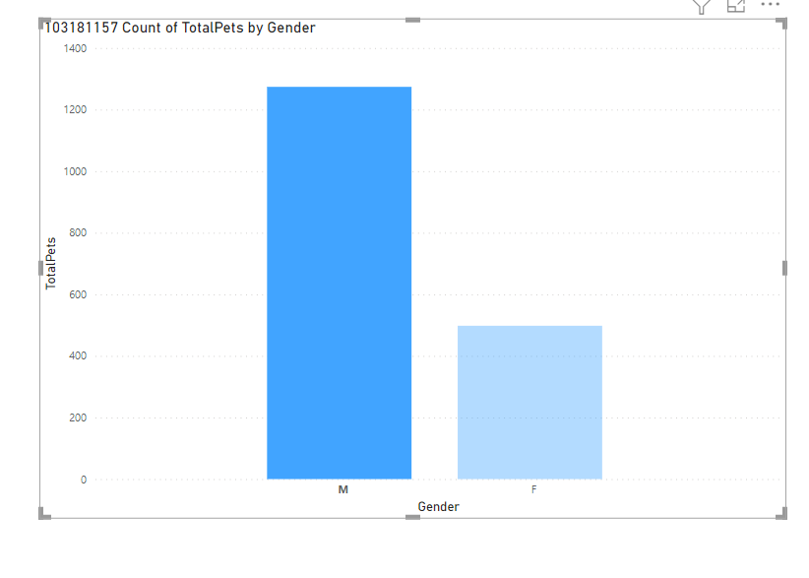

### Credit 2g

Paste your screen capture(s) for this task here.

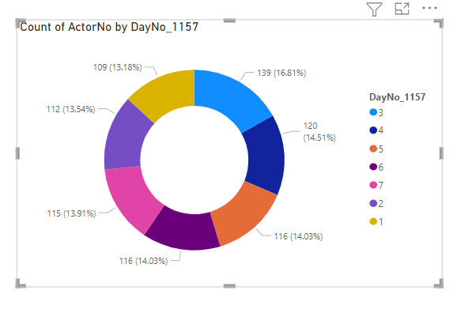

### Credit 2h

Paste your screen capture(s) for this task here.

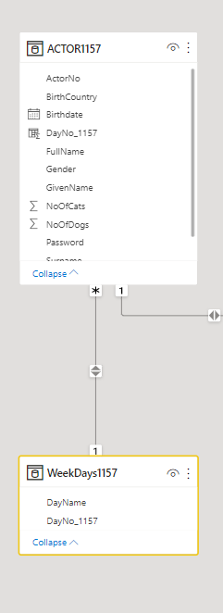

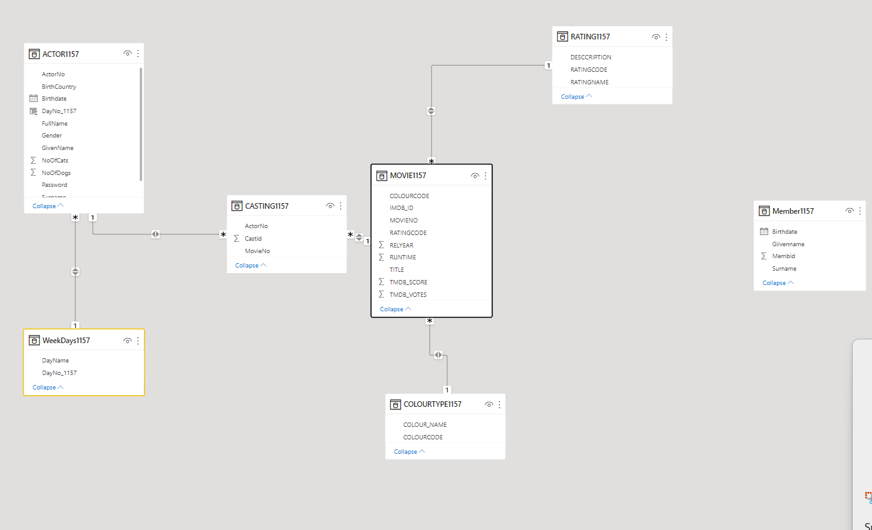

### Credit 2i

Paste your screen capture(s) for this task here.

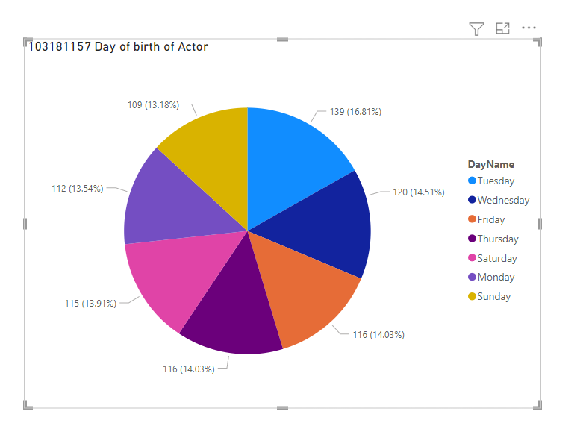

### Credit 2j

Paste your screen capture(s) for this task here.

